AAC 2023 - Conference & Exhibition
International Convention Centre, Birmingham
13-14 March 2023

Date : Stand No :
Company Name : Contact Name :
Company Address :
Post Code :
Contact Tel No : Email :

GP1 Infill Graphics £165 GP2 Seamless Graphics £205
Per 1m wide (apx) Panel Section
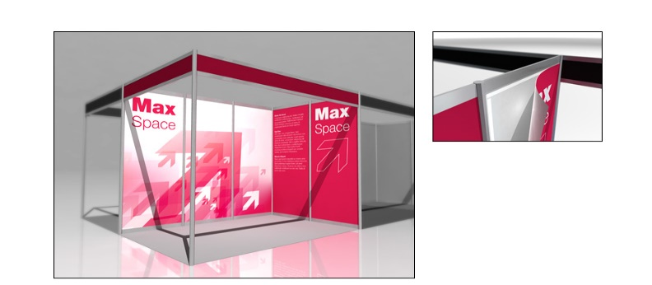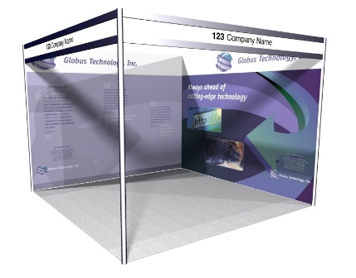

 | Full Height Foamex Panel System Graphic Options | Unit Price | Qty | Total
GP1 | Full Colour Graphic Infill Panel @ 2340mm H x 950mm W | £165.00
GP1a | Full Colour Graphic Infill Panel @ 2340mm H x 455mm W | £110.00
GP2 | Full Colour Graphic Seamless Panel @ 2.5m x 1m W (approx) | £205.00
DX1 | Graphic Panel Disposal Charge (Per Panel) | £10.00
 |  | Sub Total
 |  | VAT | 20%
 |  | TOTAL
All artwork to be pre-prepared and supplied by Exhibitor – High Resolution PDF Format
All Graphic Orders to be received no later than the 24th Febraury 2023

Full payment required with receipt of order. BACS Electronic Bank payment details will be provided on relevant Invoice as raised. Cheques to be made payable to “Lion Exhibition Services Ltd”.
To process your order, please complete above order form, Scan completed form and Email to info@lionexhibitions.com. If you do have any queries please contact Andy Guest :- +44 (0)7826 906514

