Manchester Gift Fair - 2022
Bowlers Exhibition Centre, Manchester
30th January – 2nd February 2022

Date : Stand No :
Shell Scheme Stand : ( ) Space Only Stand: ( )
Company Name : Contact Name :
Company Address :
Post Code :
Contact Tel No : Email :

GP1 Infill Graphics £135.00 GP2 Seamless Graphics £175.00
Per 1mtr Wide (apx) Panel Section
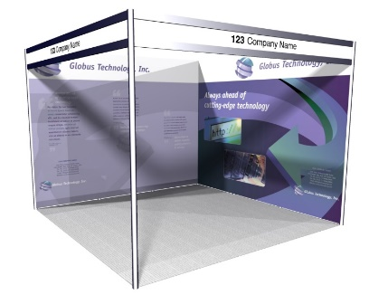

 | Full Height Foamex Panel System Graphic Options | Unit Price | Qty | Total
GP1 | Full Colour S/S Graphic Infill Panel @ 2354mm H x 970mm W | £135.00
GP2 | Full Colour S/S Graphic Seamless Panel @ 2.4m x 1m W (apx) | £175.00
DX1 | Graphic Panel Disposal Charge (Per 1m Wide Panel) | £10.00
 |  | Sub Total
 |  | VAT | 20%
 |  | TOTAL
All artwork to be pre-prepared and supplied by Exhibitor – Hi Resolution PDF Files

All Graphic Orders to be received no later than the 14th January 2022
Full payment required with receipt of order. BACS Electronic Bank payment details will be provided on relevant Invoice as raised. Cheques to be made payable to “Lion Exhibition Services Ltd”.
To process your order, please complete above order form, Scan completed form and Email to info@lionexhibitions.com. If you do have any queries please contact Tony Holden :- +44 (0)7701 026181

