Future Propulsion Conference 2023
Manxman Suite
National Motorcycle Museum, Birmingham
1st - 2nd March 2023

Date : Stand No :
Company Name : Contact Name :
Company Address :
Post Code :
Contact Tel No : Email :

GP1 Infill Graphics £150 per panel GP2 Seamless Graphics £190.00 per panel
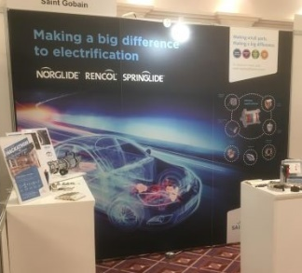
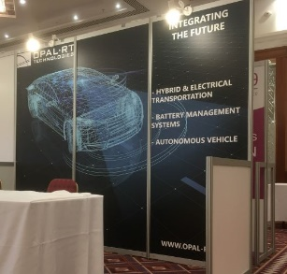
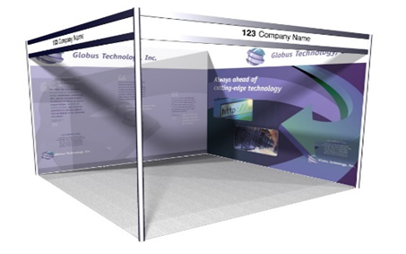
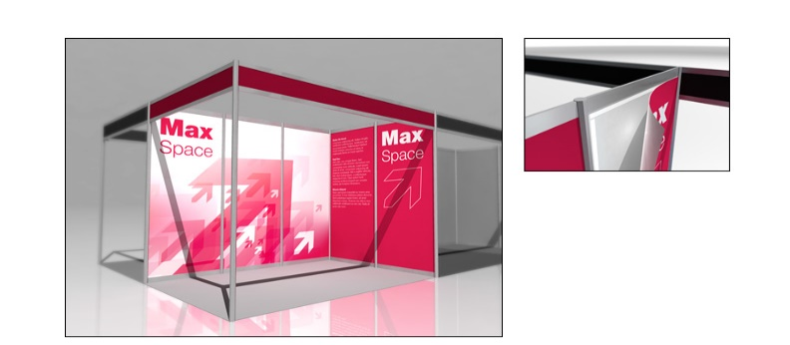

 | Full Height Foamex Panel System Graphic Options | Unit Price | Qty | Total
GP1 | Full Colour Graphic Infill Panel @ 2354mm x 970mm W | £150.00
GP2 | Full Colour Graphic Seamless Panel @ 2.5m x 1m W (apx) | £190.00
GP3 | Full Colour S/S Graphic Infill Panel @ 880mm H x 950mm W | £90.00
DX1 | Graphic Panel Disposal Charge (Per Panel) | £10.00
 |  | Sub Total
 |  | VAT | 20%
 |  | TOTAL

All artwork to be pre-prepared and supplied by Exhibitor
All Graphic Orders to be received no later than the 13th February 2023
Full payment required with receipt of order. BACS Electronic Bank payment details will be provided on relevant Invoice as raised. Cheques to be made payable to “Lion Exhibition Services Ltd”.
To process your order, please complete above order form, Scan completed form and Email to info@lionexhibitions.com. If you do have any queries please contact Andy Guest :- +44 (0)7826 906514

