Inspiring Leadership Conference 2022
ICC, Birmingham
28-29th June 2022

Date : Stand No :
Shell Scheme Stand : ( ) Space Only Stand: ( )
Company Name : Contact Name :
Company Address :
Post Code :
Contact Tel No : Email :

GP1 Infill Graphics £140.00 GP2 Seamless Graphics £180.00
Per 1mtr Wide (apx) Panel Section
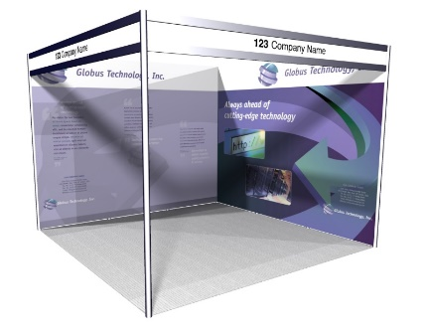

 | Full Height Foamex Panel System Graphic Options | Unit Price | Qty | Total
GP1 | Full Colour S/S Graphic Infill Panel @ 2354mm x 970mm W | £140.00
GP2 | Full Colour S/S Graphic Seamless Panel @ 2.5m x 1m W (apx) | £180.00
DX1 | Graphic Panel Disposal Charge (Per Panel) | £10.00
 |  | Sub Total
 |  | VAT | 20%
 |  | TOTAL
All artwork to be pre-prepared and supplied by Exhibitor – High Resolution PDF Format
All Graphic Orders to be received no later than 6th June 2022

Full payment required with receipt of order. BACS Electronic Bank payment details will be provided on relevant Invoice as raised. Cheques to be made payable to “Lion Exhibition Services Ltd”.
To process your order, please complete above order form and Email to info@lionexhibitions.com.
If you have any queries please contact Andy Guest :- +44 (0)7826 906514

