AAC 2024 - Conference & Exhibition
International Convention Centre, Birmingham
26-27th February 2024

Date : Stand No :
Company Name : Contact Name :
Company Address :
Post Code :
Contact Tel No : Email :

GP1 Infill Graphics £170 GP2 Seamless Graphics £210
Per 1m wide (apx) Panel Section
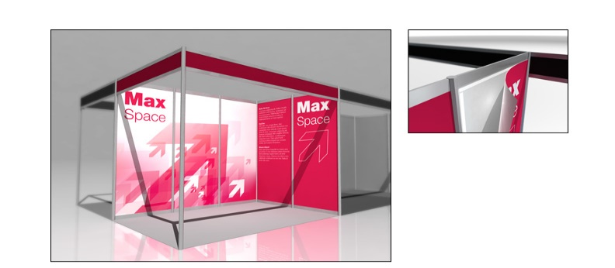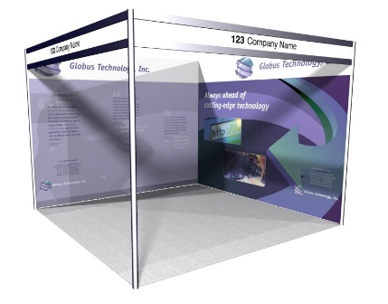

 | Full Height Foamex Panel System Graphic Options | Unit Price | Qty | Total
GP/A | Full Colour Graphic Infill Panel @ 2340mm H x 950mm W | £170.00
GP/B | Full Colour S/S Graphic Infill Panel @ 2340 mm H x 660mm W | £120.00
GP/SS | Full Colour Graphic Seamless Panel @ 2.5m x 1m W (approx) | £210.00
GP/C | Full Colour S/S Graphic Infill Panel @ 880mm H x 950mm W | £80.00
DX1 | Graphic Panel Disposal Charge (Per Panel) | £10.00
 |  | Sub Total
 |  | VAT | 20%
 |  | TOTAL
All artwork to be prepared and supplied by Exhibitor in High Resolution PDF Format
All Graphic Orders to be received no later than the 5th February 2024
Full payment required with receipt of order.
BACS Electronic Bank payment details will be provided on Invoice.
To process your order, please complete above order form, scan and Email to info@lionexhibitions.com.
If you have any queries please contact Andy Guest :- +44 (0)7826 906514

