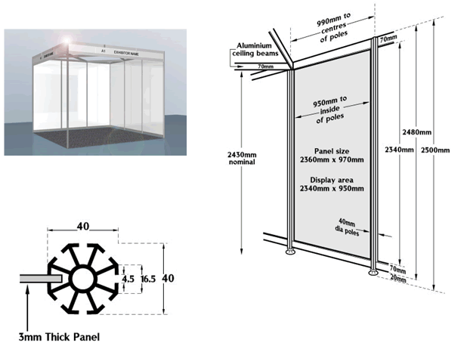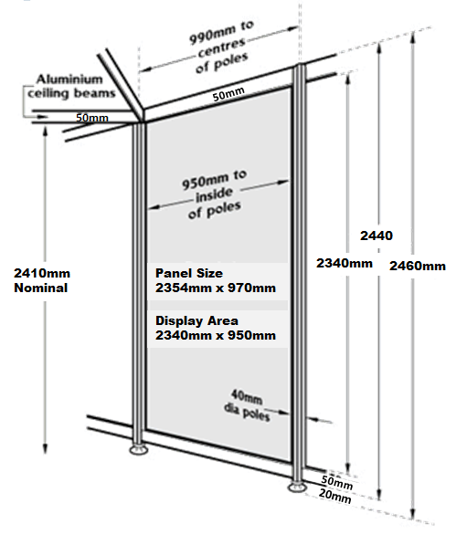
Foamex Panel / Metalwork Fixings Do’s & Do Not’s
Permitted Strictly Not Permitted

Blu Tack Products Hammer / Nail Fixings
Double Sided Mesh Tape - Screw / Staple Fixings
Available from Lion Exhibitions Liquid Bonding Agents (Glue)
Packaging Tape / Sellotape
Double Sided Adhesive Tape
Double Sided Adhesive Foam Tape
Velcro Hook & Loop Tape

