Futurescape 2021
ExCeL London
16th – 17th November 2021

Date : Stand No :
Company Name : Contact Name :
Company Address :
Post Code :
Contact Tel No : Email :
Shell Scheme System Stand Area Required on Hire for Duration of Event :-
Ref | Shell Scheme System – Exhibitor Stand Area | Unit Price Per M² | Qty | Total
SSSA | Shell Scheme System – Featuring :- | £30.00
Silver aluminium metalwork, white foamex infill panels and built to an overall height of 2.46m.
260mm stand Fascia area to incorporate white foamex infill panels, featuring client name and stand No details applied directly to each open stand side.
M² rate inclusive of Black Cord Carpet installed direct to venue floor (Carpet colour options available).
 | 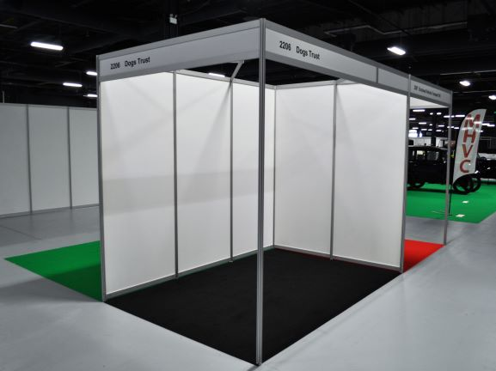
 | Shell Scheme Stand Area Inclusive of Cord Carpet – Sample Pricing :- | Total
SS3x2 | Shell Scheme Stand Area & Carpet – 3m x 2m | £180.00
SS3x3 | Shell Scheme Stand Area & Carpet – 3m x 3m | £270.00
SS4x3 | Shell Scheme Stand Area & Carpet – 4m x 3m | £360.00
SS6x4 | Shell Scheme Stand Area & Carpet – 6m x 4m | £720.00
 |  | Sub Total
 |  | VAT | @ 20%
 |  | TOTAL

Futurescape 2021
ExCeL London
16th – 17th November 2021

Company Name : Shell Scheme Stand No :
Stand Dimensions : M X M

Please indicate stand size, orientation and illustrate positioning of required Shell Scheme Stand Area :-

Grid - Instruction Points to consider :-
- Each square on the grid can denote 1 M² or 0.5 M² …. etc.
- Draw the outline of your stand showing BACK & SIDE WALLS required.

Stand Area Frontage

Please Advise Below, Client Nameboard Details Required – Maximum 35 Characters.
Please indicate exactly how you wish fascia area text to appear – Lower / Upper Case Text.

All Shell Scheme Stand Area Orders to be received no later than the 27th October 2021
Orders not received by above date will be subject to a 20% Surcharge.

Full payment required with receipt of order. BACS Electronic Bank payment details will be provided on relevant Invoice as raised. Cheques to be made payable to “Lion Exhibition Services Ltd”.

To process your order, please complete above order form, Scan completed form and Email to info@lionexhibitions.com. If you do have any queries please contact Tony Holden :- +44 (0)7701 026181

