Reinventing Space Conference 2021
QEII Centre, London – 5th Floor
28th – 30th June 2021

Date : Stand No :
Shell Scheme Stand : ( ) Space Only Stand: ( )
Company Name : Contact Name :
Company Address :
Post Code :
Contact Tel No : Email :
GP1 Infill Graphics £135.00 GP2 Seamless Graphics £175.00
Per 1mtr Wide (apx) Panel Section
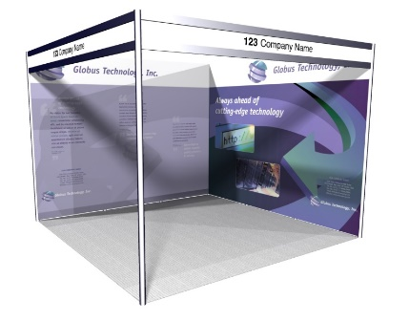

 | Full Height Foamex Panel System Graphic Options | Unit Price | Qty | Total
GP1 | Full Colour S/S Graphic Infill Panel @ 2354mm H x 970mm W | £135.00
GP2 | Full Colour S/S Graphic Seamless Panel @ 2.4m H x 1m W (apx) | £175.00
DX1 | Graphic Panel Disposal Charge (Per Panel) | £10.00
 |  | Sub Total
 |  | VAT | 20%
 | Artwork to be Presented as Hi-Res PDF Files | TOTAL
All Artwork to be pre-prepared and supplied by Exhibitor
All Graphic Orders and Associated Artwork to be Received no Later than the 11th June 2021

Full payment required with receipt of order. BACS Electronic Bank payment details will be provided on relevant Invoice as raised. Cheques to be made payable to “Lion Exhibition Services Ltd”.
To process your order, please complete above order form, Scan completed form and Email to info@lionexhibitions.com. If you do have any queries please contact Tony Holden :- +44 (0)7701 026181

