Future Propulsion Conference 2022
Manxman Suite
National Motorcycle Museum, Birmingham
2nd-3rd March 2022

Date : Stand No :
Company Name : Contact Name :
Company Address :
Post Code :
Contact Tel No : Email :

GP1 Infill Graphics £135 per panel GP2 Seamless Graphics £180.00 per panel

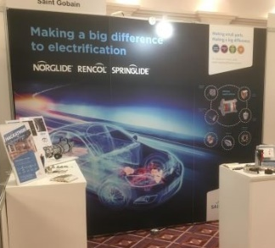
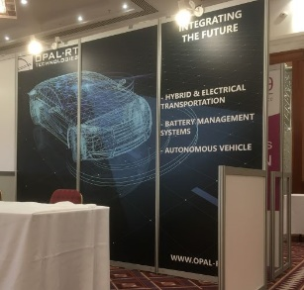
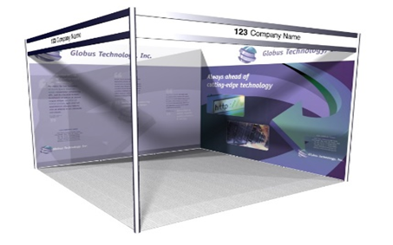

 | Full Height Foamex Panel System Graphic Options | Unit Price | Qty | Total
GP1 | Full Colour Graphic Infill Panel @ 2354mm x 970mm W | £135.00
GP2 | Full Colour Graphic Seamless Panel @ 2.5m x 1m W (apx) | £180.00
DX1 | Graphic Panel Disposal Charge (Per Panel) | £10.00
 |  | Sub Total
 |  | VAT | 20%
 |  | TOTAL
All artwork to be pre-prepared and supplied by Exhibitor
All Graphic Orders to be received no later than the 18th February 2022

Full payment required with receipt of order. BACS Electronic Bank payment details will be provided on relevant Invoice as raised. Cheques to be made payable to “Lion Exhibition Services Ltd”.
To process your order, please complete above order form, Scan completed form and Email to info@lionexhibitions.com. If you do have any queries please contact Andy Guest :- +44 (0)7826 906514

